**LiveMusicSearch Page Design**

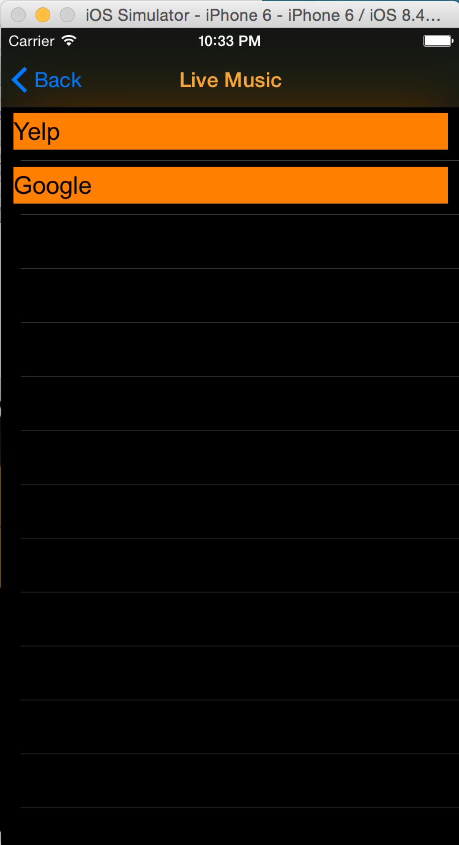**Elements:**

Title: “Live Music”, orange

Navigation Buttom: “Back”, blue; back to last page(menu)

View Backgroud: black

Cell Background: orange

Cell content:

black text

search engine name(“Yelp”, “Google”)